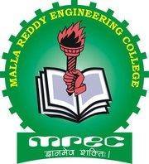
MALLA REDDY ENGINEERING COLLEGE
(AUTONOMOUS)
Maisammaguda, Dhulapally (Via kompally), Secunderabad - 500100.

DEPARTMENT OF CYBER SECURITY
Date: 28-09-2024

Academic Year: 2024-25

S.NO | NAME OF THE  STUDENT | STUDENT ACHIVEMENTS | DATE | ORGANIZED/SPONSORED BY
1 | M.Praneesh  Mr.Govinda  Mr.Karthikeyan  Mr.Jaswanth  Mr.Viswa Chaitanya | First Prize for event “Travel Voyage” in  VISHESH-2K24 | 28-09-2024 | MREC(A),Secunderabad
2 | Mr. Ayush Prasd  A.Harshith  K.Akshaya  M.Druvitha  G.Geethika | Second Prize for event “Visionary Pointetr : The Eye Mouse Curser ” in VISHESH-2K24 | 28-09-2024 | MREC(A),Secunderabad
3 | K.Giri Prasad  K.Ram Kishore  P.Jayanth  B.Raju  K.Sriram | Third Prize for event “Agro Target” in  VISHESH-2K22 | 28-09-2024 | MREC(A),Secunderabad

